TAPM: Tracking Activity Project Management

Project Documentation Submitted to the Faculty of the

School of Computing and Information Technologies

Asia Pacific College

In Partial Fulfillment of the Requirements for

Applied Project – System Prototype for

CS SCSPROJ

By

|  |  |
| --- | --- |
| Bea Angeline Cruz | Jose Norberto Verde |
| Mark Gerald Giba | Joseph Adrian Lebag |
| Noreen Keziah Sioco |  |

ASIA PACIFIC COLLEGE

Approval Sheet

TAPM: Tracking Activity Project Management

Prepared and submitted by

Bea Angeline Cruz Mark Gerald Giba

Noreen Keziah Sioco Jose Norberto Verde

Joseph Adrian Lebag

In Partial Fulfillment of the Requirements for the Degree of

Bachelor of Science in Computer Science

Examined and Recommended for Acceptance and Approval for

Research/Capstone Presentation

___ ______

Mr. Manuel Sebastian S. Sanchez, Adviser

Panelists

___________________________

<Name>, Chairperson

|  |  |
| --- | --- |
| ___________________________ | ___________________________ |
| Ms. Jo Anne M. De La Cuesta, Panel Member | Mr. Alvin C. Limpin, Panel Member |

Acceptance and Approved in Partial Fulfillment of the Requirements for the Degree of

Bachelor of Science in Computer Science

___________________________

Rhea-Luz R. Valbuena

Executive Director

School of Computing and Information Technologies

Table of Contents

Abstract i

List of Figures ii

List of Tables iv

I. Introduction 1

1.1 Project Context 1

1.2 Statement of the Problem 2

1.3 Objectives 2

1.4 Significance of the Project 2

1.5 Scope and Limitations 2

II. Review of Related Literature / Systems 4

III. Technical Background 5

3.1 Current System 5

3.2 Proposed System 5

IV. Methodology 6

5.1 Requirements Analysis 6

5.1.1 Product Backlog / User Stories 6

5.1.2 Event Tables 7

5.1.3 Use Case Diagrams 8

5.1.4 Use Case Full Description 9

5.2 Gap Analysis 11

5.3 System Analysis and Design 12

5.3.1 Context Diagram 12

5.3.2 Data Flow Diagrams 13

5.3.3 Entity-Relationship Diagrams 17

5.3.4 Activity Diagrams 19

5.3.5 Object Diagrams 24

5.3.6 Class Diagrams 24

5.3.7 Sequence Diagrams 25

5.3.8 State Machine Diagram 26

5.3.9 Deployment Diagram 28

V. Results and Discussion 29

6.1 Release Plan 29

6.2 Prototype 29

6.3 Use Classes and Characteristics 39

VI. Conclusion 39

References 40

Appendices 41

Appendix A: Project Vision 41

Appendix B: Schedule 42

Appendix C: Product Roadmap 43

Appendix E: Team Meetings 44

Appendix F: Source Code 47

# Abstract

The current global circumstances have impacted the education sector. With a shift to online learning, students and educators have difficulty collaborating, especially in the project development process. However, conducting classes and monitoring student progress through virtual platforms such as Microsoft Teams and Zoom can be challenging for teachers, particularly at the college level. This study was conducted to address the specific struggles of the Project Development Office (PDO) of Asia Pacific College, in keeping track of multiple student research teams. The researchers proposed a solution in the form of a project tracker platform: a combination of Microsoft Planner, GitHub, and Trello with added functionality for documentation, messaging, feedback, and progress tracking. The platform aims to alleviate the workload of the PDO and improve overall communication and progress monitoring for student research teams. The project tracker is scheduled to be implemented by the end of AY 2022-2023.

# List of Figures

Figure 1 Use Case Diagram 8

Figure 2 Fishbone Diagram 12

Figure 3 Context Flow Diagram of TAPM 12

Figure 4 Level 0 Data Flow Diagram of TAPM 13

Figure 5 Level 1 Data Flow Diagram of TAPM Process 1 Manage Group Project 14

Figure 6 Level 1 Data Flow Diagram of TAPM Process 2 Manage Task 15

Figure 7 Level 1 Data Flow Diagram of TAPM Process 3 Update Project 16

Figure 8 Level 1 Data Flow Diagram of TAPM Process 4 Send Feedback 17

Figure 9 Level 2 Data Flow Diagram of TAPM Review Revision 17

Figure 10 Entity Relationship Diagram of TAPM 18

Figure 11 Activity Diagram for Admin of TAPM 19

Figure 12 Activity Diagram for Adviser/Consultant of TAPM 20

Figure 13 Activity Diagram for Project Development Office of TAPM 21

Figure 14 Activity Diagram for Student of TAPM 22

Figure 15 Activity Diagram for Teacher of TAPM 23

Figure 16 Object Diagram of TAPM 24

Figure 17 Class Diagram of TAPM 24

Figure 18 Sequence Diagram of TAPM for Login 25

Figure 19 Sequence Diagram of TAPM for all Users 26

Figure 20 State Machine Diagram of TAPM for Add Project 26

Figure 21 State Machine Diagram of TAPM for Create Group Project 27

Figure 22 State Machine Diagram of TAPM for Manage Task 27

Figure 23 Deployment Diagram of TAPM 28

Figure 24 Data Migration and Seeded Users of TAPM prototype. 29

Figure 25 Login Screen of TAPM 30

Figure 26 Home Page of Teacher/Adviser/PDO View of TAPM 30

Figure 27 Pop Up Modal for Add Group of TAPM 31

Figure 28 Success Message for successful addition of Group Project 31

Figure 29 Home page of Teacher/Adviser/PDO after Group Project Creation of TAPM 31

Figure 30 Card Action for Teacher/Adviser/PDO view of TAPM 32

Figure 31 Home Page of Student after permission given. 32

Figure 32 Project page of Teacher/Adviser/PDO view of TAPM 32

Figure 33 Project page of Student view of TAPM 32

Figure 34 Pop Up Modal for Project/Updates Creation of TAPM 33

Figure 35 Project Page after Successfully added Projects. 33

Figure 36 Feedbacks Section at Project Page of TAPM 34

Figure 37 Task Page of TAPM for Teacher View 34

Figure 38 Task Page of TAPM for Adviser/PDO/Student View 34

Figure 39 Pop Up Modal for Adding Task of TAPM 35

Figure 40 Task Page after Task Creations 35

Figure 41 Task Page after marking all Tasks as Finished 35

Figure 42 Team Page of TAPM with List of Members for Teacher/Adviser/PDO 36

Figure 43 Pop up Modal for adding and giving permission to users to view the Project 36

Figure 44 List of Members at Team Page of TAPM 36

Figure 45 Team Page of TAPM for Students View 36

Figure 46 Button to Admin View of TAPM for PDO 37

Figure 47 Pop Up Modal for Confirmation of Admin View 37

Figure 48 Welcome Page of Admin View of TAPM 37

Figure 49 User Data Table Page of Admin View of TAPM 37

Figure 50 Pop Up Modal of Add New User for Admin of TAPM 38

Figure 51 Seeded View after Successful Addition of Users 38

Figure 52 Group Project Data Table Page of Admin View of TAPM 38

Figure 53 Project Data Table Page of Admin View of TAPM 38

Figure 54 Tasks Data Table Page of Admin View of TAPM 39

Figure 55 Feedback Data Table Page of Admin View of TAPM 39

Figure 56 Schedule Run of TAPM 43

Figure 57 Schedule Chart of TAPM 43

Figure 58 Source Code at GitHub 48

# List of Tables

Table 1 Product Backlog 6

Table 2 Event Table 7

Table 3 Use Case Full Description for Manage Group Project 9

Table 4 Use Case Full Description for Update Project 9

Table 5 Use Case Full Description for Send Feedback 10

Table 6 SWOT analysis 11

Table 7 Roles and Description of Use Classes 39

Table 8 Product Roadmap of the Project 44

# Introduction

Each individual faces unique challenges daily which can cause stress. A "tracker," as defined by the Merriam-Webster Dictionary, is a record or data that is kept, typically in the form of a track. Users, clients, and researchers who are building this product are some of the people who are most prone to stress because of projects. [1]

According to Kissflow, one of the most common problems in project management is lack of communication. In the article, it further explains that miscommunication is also dangerous for project teams. The reason communication is crucial among team members is that it affects their teamwork. Poor communication can cause conflicts among team members and potentially delay the project and one of the most impacted areas in these conditions is education, particularly students and instructors, who have grown more prone to misunderstanding and poor project management.

Many contemporary problems have been solved with the help of technology through various applications and platforms specifically developed for educational purposes; however, these existing platforms each have their own purpose, uniqueness, and limitations, forcing users to use multiple platforms for a specific feature or experience they require, resulting in delays, a lot of time, chaotic files, and disorganized work.

## Project Context

The office of Asia Pacific College's PDO, whose job is to reach out to industry partners to discuss a project development partnership to provide their needs. After a discussion, the Director of the PDO will assign a student project group to the industry partner client to commence work on a project following a discussion. Once the office has completed its tasks, they must continue to monitor and track the project's progress for frequent and end reports.

The Project Development Director's office currently uses Office 365 software for project management; however, the platform has limitations and flaws that cause the office to have many challenges. Therefore, this project proposal is designed to provide a solution for the office of the Project Development Director's problems, which include their work responsibilities that include project management. The proponents are entrusted to find a way to help alleviate the issues by creating a collaborative platform with additional features that can help monitor, track, participate and make reports easier. With these additional features, the office project management and tracking capabilities can be improved, and generation of reports can be made easier.

## Statement of the Problem

The PDO of Asia Pacific College has difficulty monitoring the school's internal and external projects promptly. Projects needed to have a clear timeline to manage expectations for the industry partners and deliver output in a timely manner.

## Objectives

This project's main goal is to develop a website/system that will keep the PDO up to date on the status of projects under the Asia Pacific College's Project Based Learning (PBL2).

To achieve this, the group will develop the system with the following intentions:

* Escalate the PDO's capacity to track projects and generate reports in a timely manner; this needs the design and deployment of software which is planned to complete during PBL1.
* Provide a well-suited collaboration space so that student groups and faculty can disseminate files, ideas, and information between PBL1 and PBL2, assisting in the timely completion of the project.

## Significance of the Project

The PDO will benefit from the project and any educator facing the same issues as the client. Educators can use the project tracker platform to track and monitor the progress of several student teams working on a single project in one place. If this project becomes effective, the project’s client work will be easier because they will not have to check each student team one at a time because this project developed by researchers would allow him to watch them all at once. The project may also possibly address the fourth Sustainable Development Goal, which is Quality Education.

## Scope and Limitations

This project aims to determine the problems of the PDO in using other tracking systems and checking multiple projects at the same time.

Scope:

The focus of this project is to allow PDO to check multiple PBL projects at the same time. Student, Adviser, and Consultant can also use the system by creating projects and tasks. The system can be implemented at the APC; it can help ensure projects are completed on time.

Limitation:

This study limits its coverage to student researchers, PDO, and Faculty members of APC who can access the system. Its main purpose is to study the PDO’s struggles to keep up with each project’s progress. This study focuses on AY 2022-2023.

# Review of Related Literature / Systems

**Trello**

Trello is a user friendly, free, and flexible tracking application which has visual ways to manage projects. This application will help you in managing your projects. Trello gives an overview of the projects that you are working on, who is collaborating with them, and how far they have gotten.

Trello is a task management tool that uses the Kanban system. (Anderson, 2010). Kanban, which translates to "card," "sign," or "billboard" in Japanese, was developed by Toyota engineers as a methodology to streamline production processes. Each employee can quickly communicate with each other using standardized cues that everyone understands instantly.

Trello creates a simplified visual project management system using boards, lists, and cards. These three basic elements provide a visual layout of your work for high-level decision-making and ground-level action-taking [2].

**Notion**

Notion is a practical note-taking application that has been designed for business users. Users can use it as an information hub to easily share files, documents, and folders with your team members. In addition to offering its users more features, the application integrates well with other tools, such as Google Drive and Slack [3].

**Microsoft Planner**

Microsoft Planner is a simple, teamwork-oriented task management tool for organizing and carrying out project tasks. It uses a visual Kanban board and task cards, which can contain details such as due dates, progress, to-do lists, tags, and file attachments. Microsoft Planner integrates with various Microsoft services, including Teams, and is accessible from anywhere through web and mobile apps for iOS and Android [4].

# Technical Background

The client primarily uses a laptop and cellular device for communication and project management with industry partners. The online applications used for communication and monitoring may vary depending on the partner organization and are often determined by the platform that is most familiar to the partnered company. The client primarily uses Teams for meetings, which is linked to their workplace at Asia Pacific College. They may also utilize Zoom due to its widespread popularity and user-friendly interface in the business setting.

The client currently uses an Excel spreadsheet for monitoring project details and collaborating with colleagues or partners through the co-authoring function. However, Excel may find it difficult to monitor progress and updates, particularly with the high number of projects and organizations the client is working with. The client may also use other applications such as Notion, Trello, and GitHub, depending on the project's platform. The client has expressed interest in a product that combines the functionality of Notion and Trello, with the aim of improving productivity and being tailored to their specific needs.

## Current System

Currently, the client relies on a laptop and mobile device to communicate with industry partners However, as the client is affiliated with a diverse range of organizations their choice of online applications for communication and monitoring varies as they aim to cater to each industry partner's preferred system. The application that the client mostly uses for meetings is Teams, which is associated with his workplace in Asia Pacific College; an optional application is Zoom due to its simplicity and popularity in business.

The client uses an Excel spreadsheet to help monitor the project details along with their colleague or partner. An Excel workbook allows collaboration with other members involved with the project called co-authoring. Although it can have its benefits, Excel may prove difficult to monitor its progress and updates made by other members using the excel workbook, especially the number of projects and organization the Client is partnered with.

## Proposed System

The system or framework we will work on is Laravel, which was suggested by our client. Laravel is a PHP web application framework which will be used to create the project website. It already has laid the foundation with complex and elegant syntax we would work with. To operate Laravel, node.js, XAMPP and packages must be installed. We would also need enough knowledge about CSS, JavaScript, HTML, PHP, and SQL to create the design, system, and forms.

The System will be requiring XAMPP to be used to create the database of each user that will log-in/sign-up which will be useful to allow the amount of access based on the data input users fill in and database for projects that will be used by the users for the program to fetch the needed data easily.

# Methodology

This chapter focuses on the researcher's journey and steps in creating the project, from locating a client to creating a prototype. Using the visuals in the paper, the readers will be able to grasp a brief image of how we made this project.

There are several approaches for project tracking, but the researchers chose the Scrum approach as the product involves a development team, product client, and advisor who helped the researchers to achieve the app that the client needs. The researchers chose Scrum as the best approach for the application as it encourages collaboration between all members of the development team, including the scrum master, development team, and product client. It also allows teams to prioritize the most important/major task, which helps ensure that the most needed task is submitted to the professors. The researchers chose Scrum as the approach because the application has a feature where the client can measure progress, which means that the client can track progress and progress of multiple projects at the same time.

## Requirements Analysis

### Product Backlog / User Stories

Table 1 Product Backlog

|  |  |  |  |  |
| --- | --- | --- | --- | --- |
| Product Backlog | | | | |
| **ID** | **As a…** | **I want to be**  **able to…** | **So that…** | **Priority** |
| 1 | Project Development Office | Increase monitoring of multiple research teams and check their progress regularly. | I can always be updated and there is nothing to miss about the updates and progress. | Must |
| 2 | Project Development Office | To view all projects of each student group in one system. | I can effectively manage and monitor the progress and completion of each project, ensure resources are allocated appropriately, and make informed decisions. | Must |
| 3 | Project Development Office | Add comments about the project progress. | I can guide the student research groups with their project. | Must |
| 4 | Student Project Group | Create cooperation with the adviser through feedback. | The adviser can cope with them | Must |
| 5 | Student Project Group | Update status about the progress of the research project. | If there are some revisions needed about the project, they can revise it immediately | Must |

|  |  |  |  |  |
| --- | --- | --- | --- | --- |
| 6 | Student Project Group | Check the adviser’s task and instructions. | Mistakes can be avoided | Must |

|  |  |  |  |  |
| --- | --- | --- | --- | --- |
| 7 | Student Project Group | Upload files and updates about the research project. | The project director can scan and have a copy of it | Must |
| 8 | Adviser | Invite students to create a project group. | Collaboration and project development can be started. | Must |
| 9 | Adviser | Participates in design development and construction development planning stage with the research teams. | The research groups can have a better idea on the project they are developing. | Must |
| 10 | Adviser | Guide research groups on creating their projects such as project proposal and project features. | The research groups will have a finer project outcome. | Must |
| 11 | Adviser | Collaborate and monitor the updates of each project team to check if they are on the right track doing their projects. | Wrong works can be avoided. | Must |

### Event Tables

Table 2 Event Table

|  |  |  |  |  |  |  |
| --- | --- | --- | --- | --- | --- | --- |
| Event |  | Trigger | Source | Use Case | Response | Destination |
| PDO wants to create a project. |  | Create button | PDO | Create project | A new project will be added to the system. | Student |
| The faculty wants to create a project. |  | Create button | Faculty | Create project | A new project will be added to the system. | Student |
| PDO wants to send feedback. |  | Add comment button | PDO | Generate report | Feedback will be added under the project. | Student project |
| The faculty wants to send feedback. |  | Add comment button | Faculty | Generate report | Feedback will be added under the project. | Student project |
| Student wants to add task |  | Add task button | Student | Add task | A new task will be added to the task board. | Task board |

### Use Case Diagrams

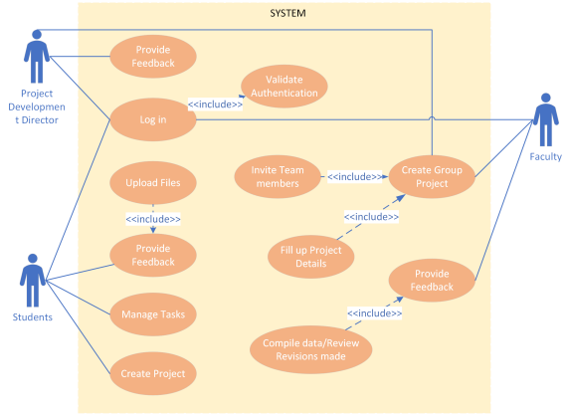

Figure 1 Use Case Diagram

### Use Case Full Description

Table 3 Use Case Full Description for Manage Group Project

|  |  |  |
| --- | --- | --- |
| **Use Case Name** | Manage Group Project | |
| **Scenario** | Faculty wants to create a project | |
| **Triggering Event** | Faculty clicks the create button | |
| **Brief Description** | Faculty creates project for students per group | |
| **Actors** | Faculty, Student, Client | |
| **Related Use Cases** | Update Project | |
| **Stakeholders** | Faculty, Student | |
| **Preconditions** | The client will create a project. | |
| **Postconditions** | The students will then access the project. | |
| **Flow of Activities** | Actors  1. Faculty/Client will create a project.  2. Faculty/Client will assign the project to the student groups. | System  1.1. The system will create the project.  2.1 After the system has created the project, it will also have a collaborative link that can be accessed by the students. |
| **Exception Conditions** | If the student failed to receive the invite, the student will email the faculty.    If a group updated their project the faculty will be notified. The faculty will review and give feedback to the group | |

Table 4 Use Case Full Description for Update Project

|  |  |  |
| --- | --- | --- |
| **Use Case Name** | Update Project | |
| **Scenario** | Student wants to revise a project | |
| **Triggering Event** | Student clicks the update button | |
| **Brief Description** | The student will update the projects according to the feedback of the client and faculty. | |
| **Actors** | Faculty, Student, Client | |
| **Related Use Cases** | Create Project | |
| **Stakeholders** | Faculty, Student, Client | |
| **Preconditions** | Faculty/client will send feedback about the project.    Students will revise the project according to the faculty/client feedback. | |
| **Postconditions** | The daily scrum bot that the application has will send notifications about the latest updates of the project. | |
| **Flow of Activities** | Actors  1. The client/faculty will send feedback about the project to students.  2. The students will then update the project regarding with the client/faculty feedback. | System  1.1. The system will send a notification with the help of our daily scrum bot about the revisions regarding the project. |
| **Exception Conditions** | If the revisions done by the students are approved, the faculty will notify the student.    If the revision of the project did not meet the deadline, the student group should notify the faculty. | |

Table 5 Use Case Full Description for Send Feedback

|  |  |  |
| --- | --- | --- |
| **Use Case Name** | Send Feedback | |
| **Scenario** | Faculty/Client want to send feedback | |
| **Triggering Event** | User clicks the feedback button | |
| **Brief Description** | When the students are done with the project, the client/faculty will generate a report about the project in progress. | |
| **Actors** | Faculty, Client, Project Director | |
| **Related Use Cases** | Update Project | |
| **Stakeholders** | Faculty, Client, Project Director | |
| **Preconditions** | The students will send the paper to the faculty/client for feedback. | |
| **Postconditions** | The client will send the feedback for the paper.    The daily scrum bot will then notify the users about the changes in the paper. | |
| **Flow of Activities** | Actors  1. Students will send the paper to their client/faculty.  2. Faculty/client will send feedback regarding the paper. | System  1.1. The system’s daily scrum bot will notify the users about the changes with the project. |
| **Exception Conditions** | If the project development director gives feedback about the project, the faculty should notify the student group about it. | |

## Gap Analysis

Table 6 SWOT analysis

|  |  |
| --- | --- |
| Strengths | Weaknesses |
| * Easier communication. * Access to files made simple. * Cooperation between organization and teams improved. | * Security and privacy may be lessened. |
| Opportunities | **Threats** |
| * Effective in reducing wasted time. Projects will be more manageable and done more effectively. * Participation for partner/team leader. | * The popularity of the website may conflict with its usability to other organizations. * Managing the website may be difficult as it is done by a small team. * Unforeseen bugs or errors that hinder productivity. |

Figure 2 Fishbone Diagram

## System Analysis and Design

### Context Diagram

Figure 3 Context Flow Diagram of TAPM

### Data Flow Diagrams

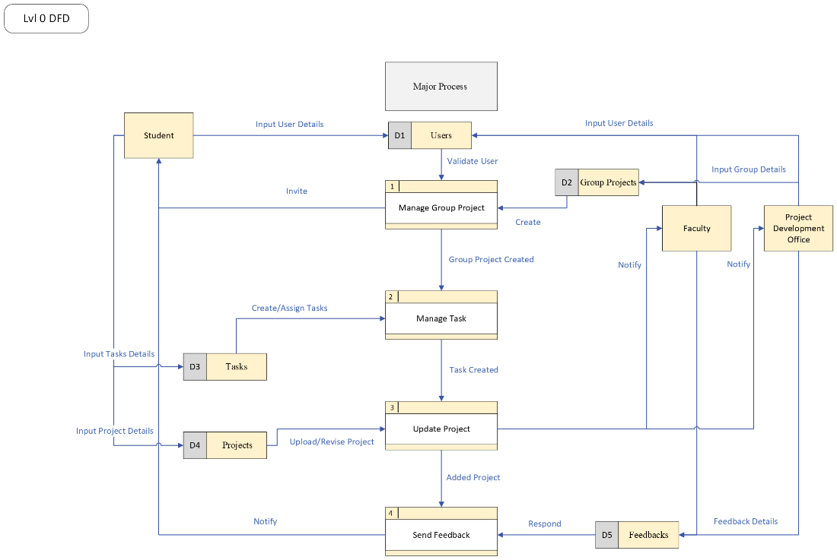

Figure 4 Level 0 Data Flow Diagram of TAPM

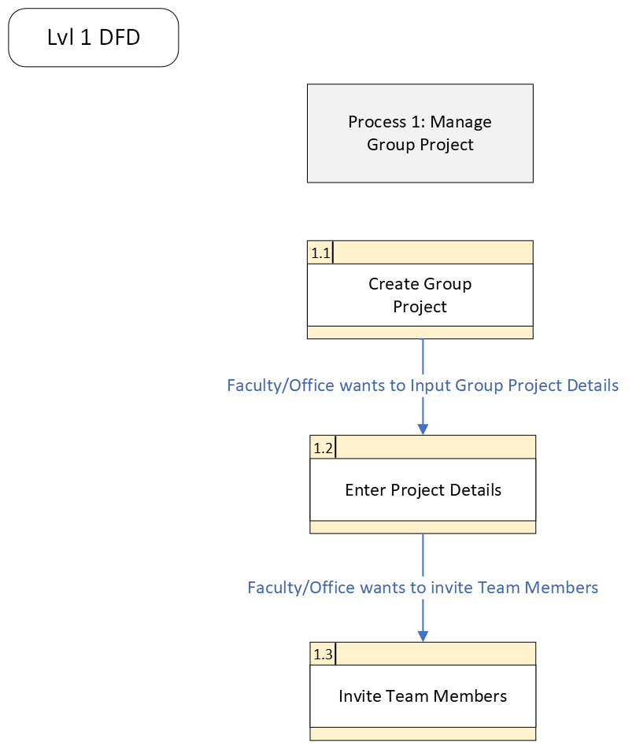

Figure 5 Level 1 Data Flow Diagram of TAPM Process 1 Manage Group Project

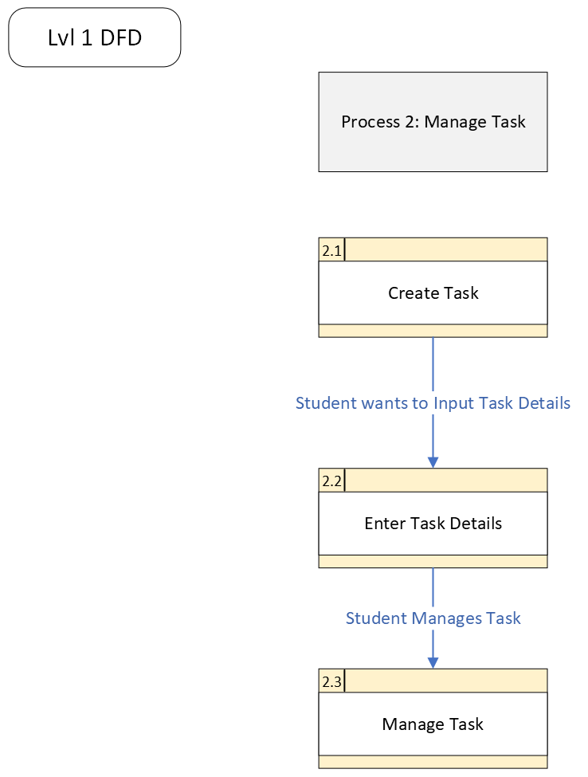

Figure 6 Level 1 Data Flow Diagram of TAPM Process 2 Manage Task

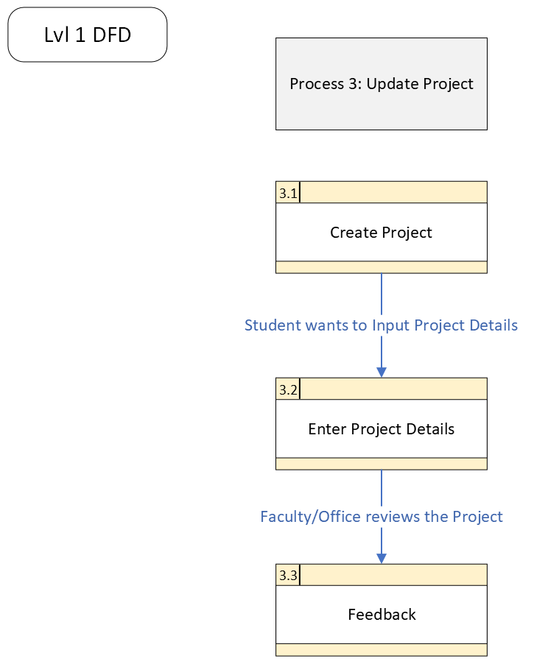

Figure 7 Level 1 Data Flow Diagram of TAPM Process 3 Update Project

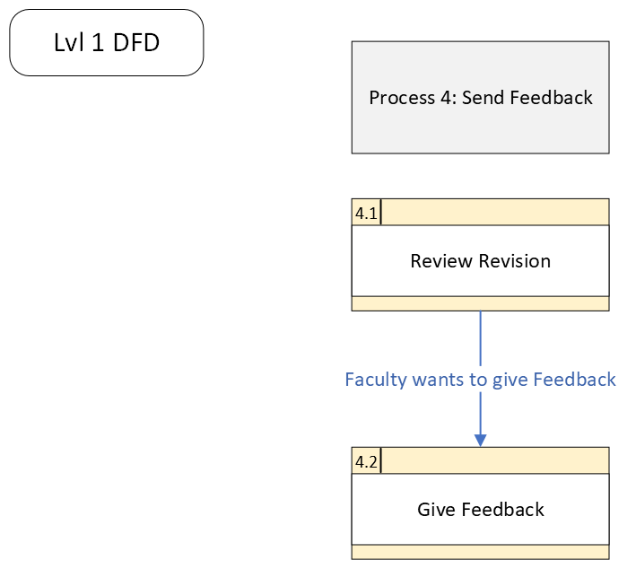

Figure 8 Level 1 Data Flow Diagram of TAPM Process 4 Send Feedback

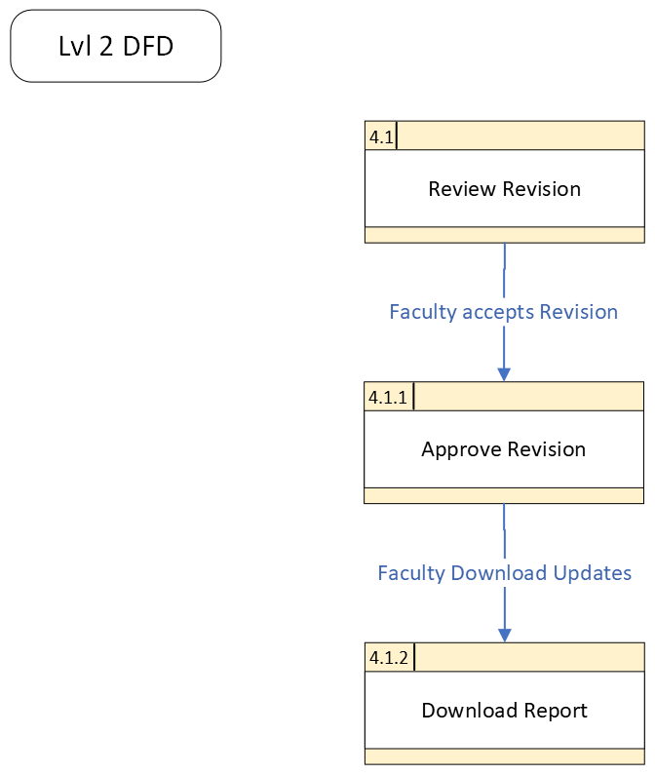

Figure 9 Level 2 Data Flow Diagram of TAPM Review Revision

### Entity-Relationship Diagrams

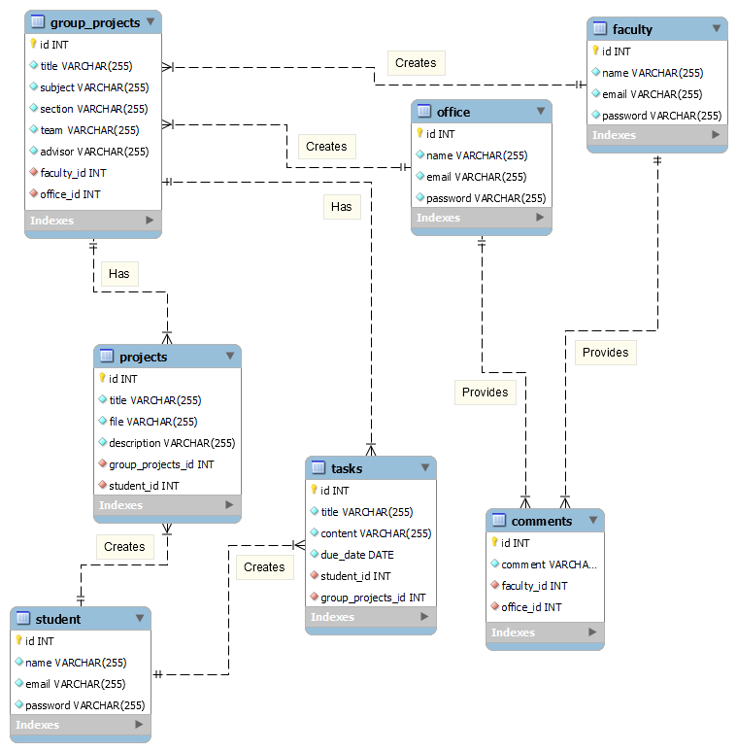

Figure 10 Entity Relationship Diagram of TAPM

### Activity Diagrams

Figure 11 Activity Diagram for Admin of TAPM

Figure 12 Activity Diagram for Adviser/Consultant of TAPM

Figure 13 Activity Diagram for Project Development Office of TAPM

Figure 14 Activity Diagram for Student of TAPM

Figure 15 Activity Diagram for Teacher of TAPM

### Object Diagrams

Figure 16 Object Diagram of TAPM

### Class Diagrams

Figure 17 Class Diagram of TAPM

### Sequence Diagrams

Figure 18 Sequence Diagram of TAPM for Login

Figure 19 Sequence Diagram of TAPM for all Users

### State Machine Diagram

Figure 20 State Machine Diagram of TAPM for Add Project

Figure 21 State Machine Diagram of TAPM for Create Group Project

Figure 22 State Machine Diagram of TAPM for Manage Task

### Deployment Diagram

Figure 23 Deployment Diagram of TAPM

# Results and Discussion

In this section, the study results are presented and discussed in relation to the research questions and hypotheses. The findings are organized and presented logically, with appropriate tables and figures used to aid in explaining the results.en interprets the results and places them in the context of the literature reviewed in the introduction. Implications of the study and suggestions for future research are also provided.

## Release Plan

Release 1:

* Users can open the website.
* Users can log in or register for an account.
* Users can browse through the homepage to see different projects and create new projects.
* Users can use the search function and filter to find the desired project.

Release 2:

* Users can view a project description and identify the type of project.
* Users can identify their current project phase using color-coded development (initiation, planning, execution, performance/monitoring, and project close)

Release 3:

* Users will receive notifications for recent project updates.
* Users can easily view daily group reports on project progress.
* Users and project teams can easily create daily scrum reports using the project board's bot.
* Users can easily view their project progress in a Gantt chart and add/update their task.
* Users can easily add and assign tasks to the team members and set due dates for the task.

## Prototype

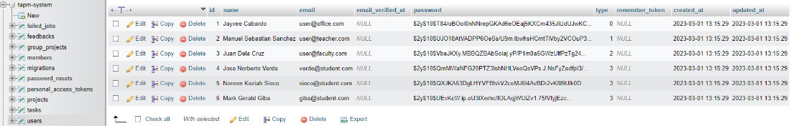

Figure 24 Data Migration and Seeded Users of TAPM prototype.

Figure 24 is the database of the system and system’s list of seeded users that can be used to login. This set of users is just an example of operating the system, which will be later removed on the initial release of the system. The database will be made with the use of XAMPP and phpMyAdmin.

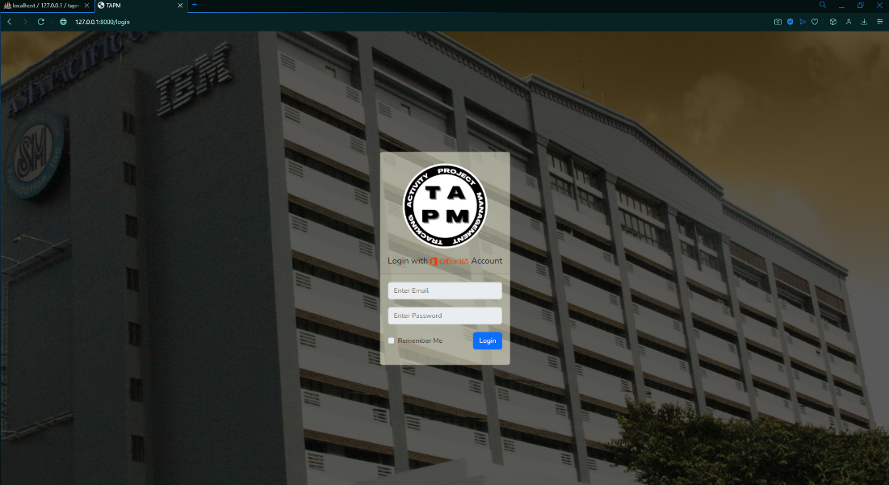

Figure 25 Login Screen of TAPM

In Figure 25, we can see the login page where the user will be prompted to enter their credentials as to access the system. APC credentials will be used to access the System.

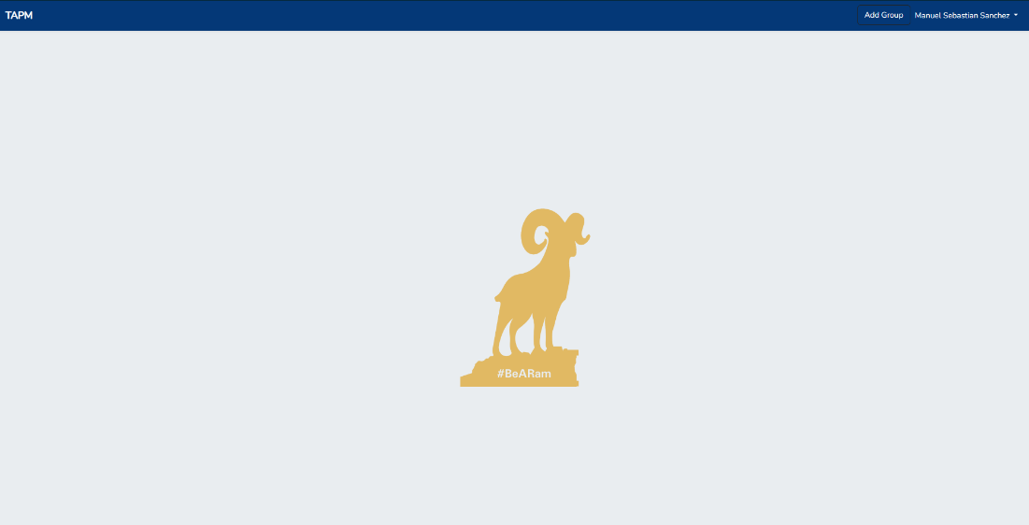

Figure 26 Home Page of Teacher/Adviser/PDO View of TAPM

Figure 26 shows the home page of the Teacher, Adviser, and PDO User. This page includes the Navigation Bar that has an option button whether to Add Group. This page will also show the list of group projects that will be made by the Teacher, Adviser, and PDO User.

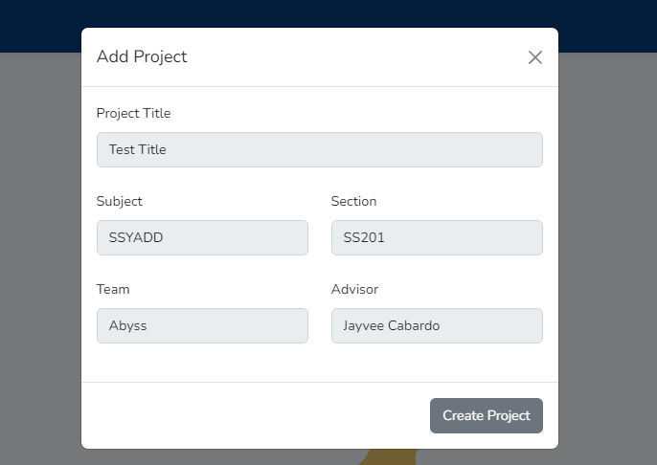

Figure 27 Pop Up Modal for Add Group of TAPM

Figure 27 is where the modal screen pops up when the Add Group button is pressed. Here, the user will be prompted to enter details as to what the Project will consist of such as its title, subject, team in charge, etc.

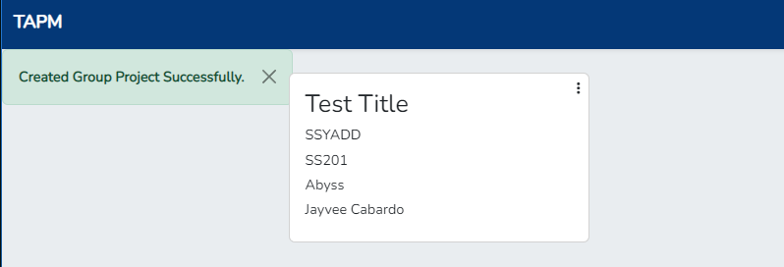

Figure 28 Success Message for successful addition of Group Project

Figure 28 shows a sample of what will be displayed in the Home Page Screen after the successful creation of the Group. This will show the list of Project that will be made through the system and that is seeded to the database.

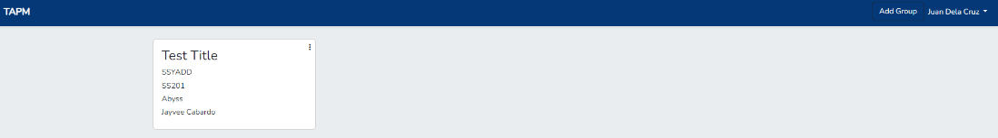

Figure 29 Home page of Teacher/Adviser/PDO after Group Project Creation of TAPM

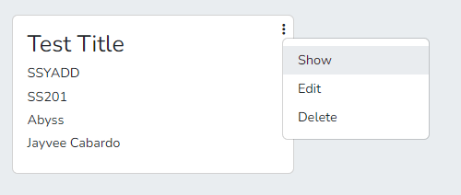

Figure 30 Card Action for Teacher/Adviser/PDO view of TAPM

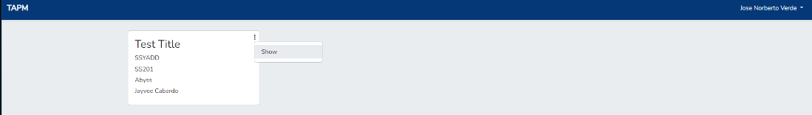

Figure 31 Home Page of Student after permission given.

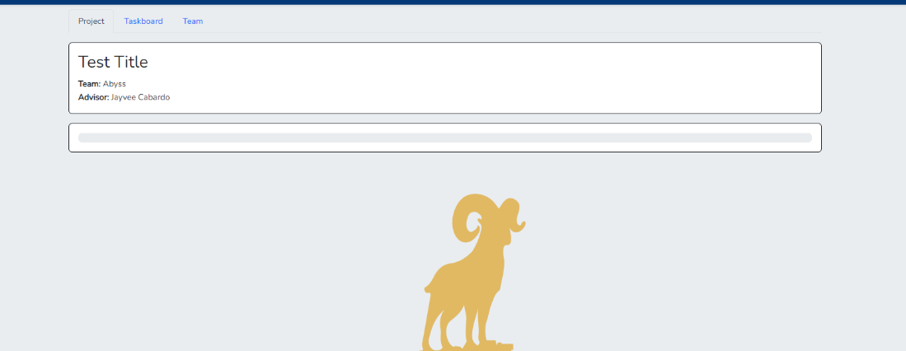

Figure 32 Project page of Teacher/Adviser/PDO view of TAPM

Figure 32 displays the Project Page, which allows to view the projects and updates made. This page will serve as the primary platform for users to document their projects and allow faculty and clients to view and provide feedback.

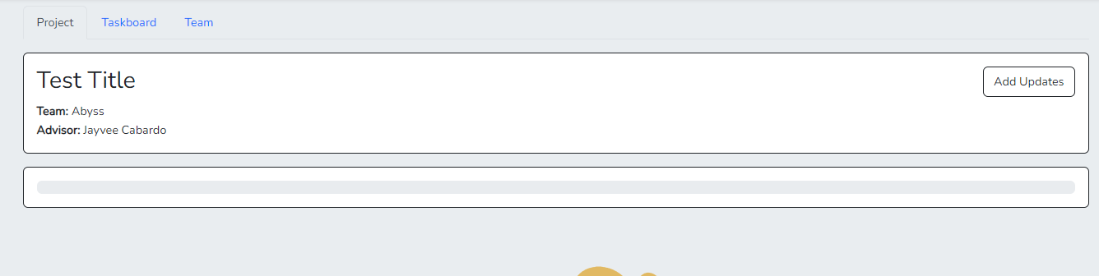

Figure 33 Project page of Student view of TAPM

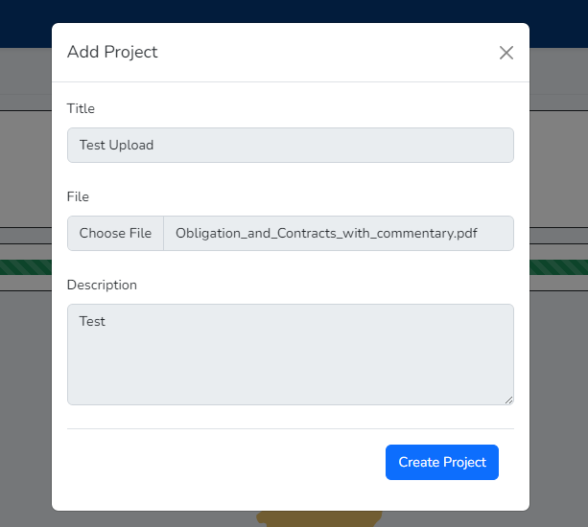

Figure 34 Pop Up Modal for Project/Updates Creation of TAPM

Figure 34 is the display modal for Adding Updates towards the project. Here, the user is prompted to enter the title of the post, the file to see, and the respective description towards the project.

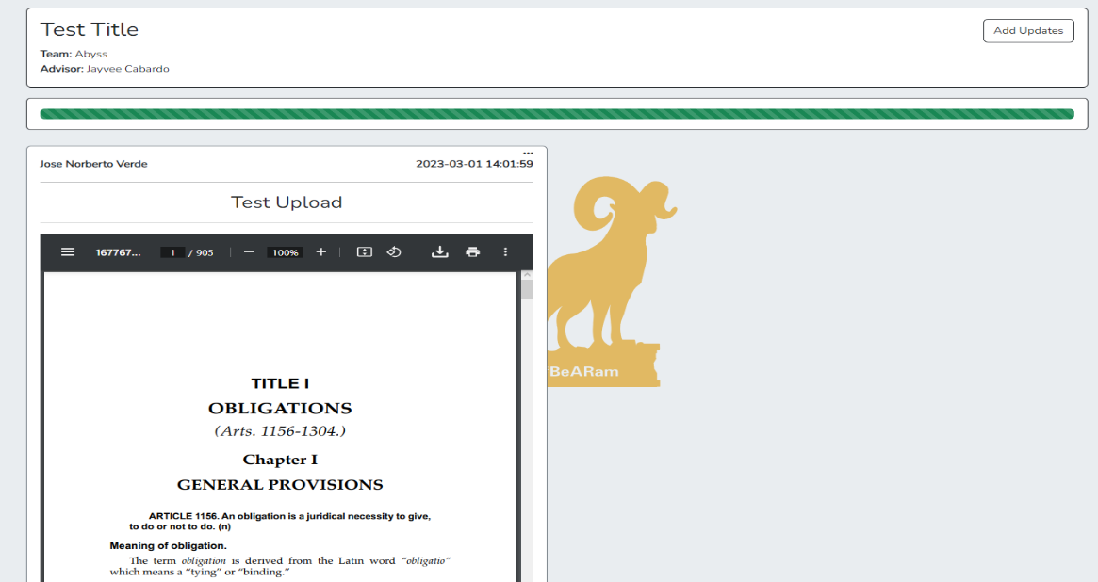

Figure 35 Project Page after Successfully added Projects.

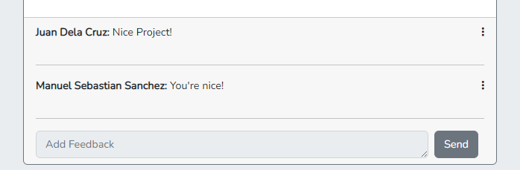

Figure 36 Feedbacks Section at Project Page of TAPM

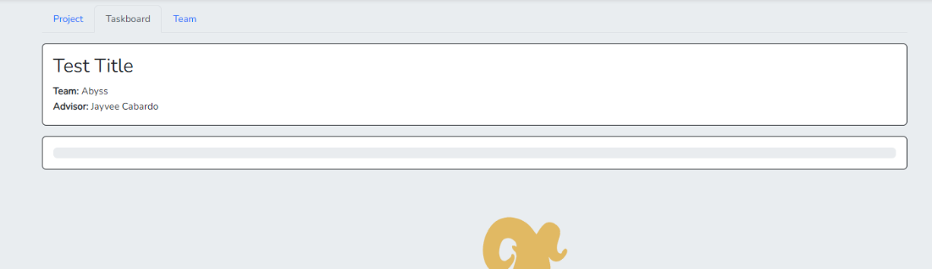

Figure 37 Task Page of TAPM for Teacher View

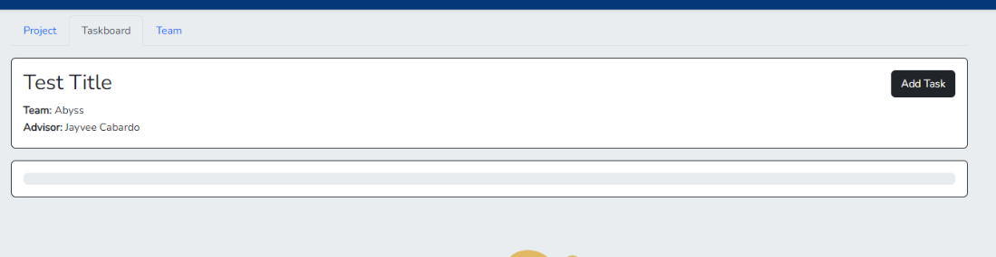

Figure 38 Task Page of TAPM for Adviser/PDO/Student View

Figure 38 shows the Task Page, which allows viewing the tasks done by the students, advisers, and the PDO. This page allows the user to see and update the tasks that are given. This page will be responsible for the tracker.

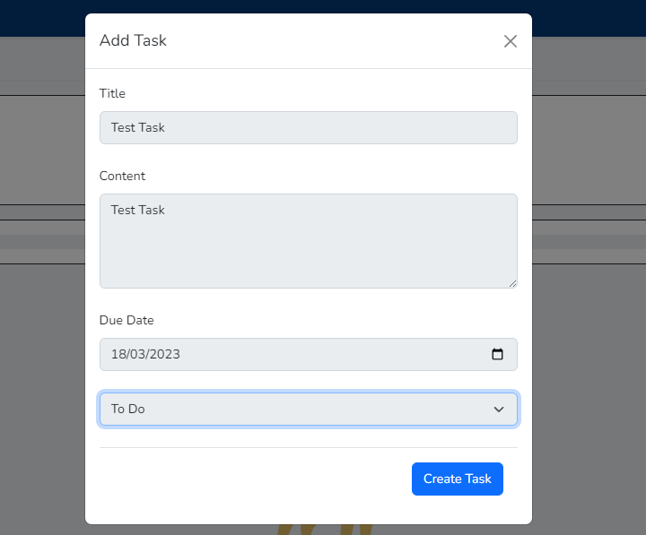

Figure 39 Pop Up Modal for Adding Task of TAPM

Figure 39 is the display modal for the Add Task button. This modal will prompt the user to enter the task details such as its title, status, etc.

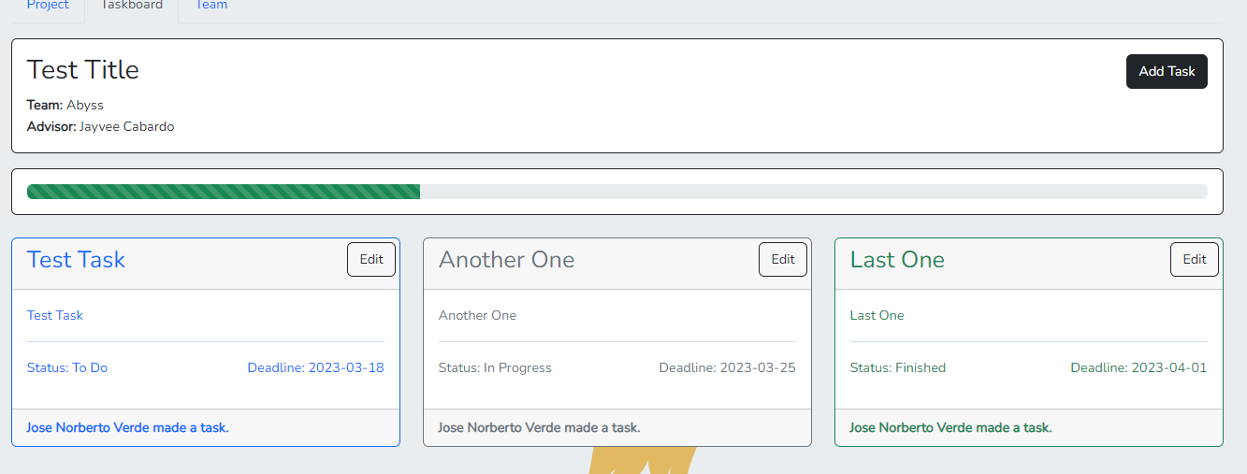

Figure 40 Task Page after Task Creations

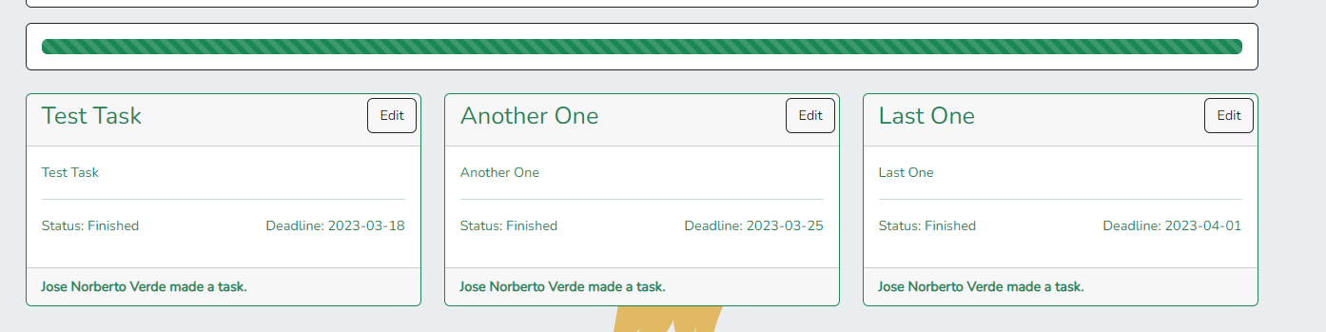

Figure 41 Task Page after marking all Tasks as Finished

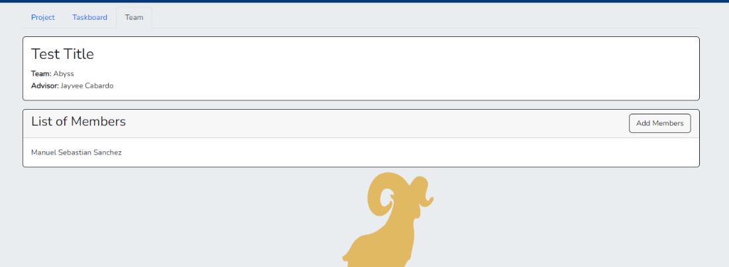

Figure 42 Team Page of TAPM with List of Members for Teacher/Adviser/PDO

Figure 42 shows the Team Page, which will let users see the list of members involved with the project creation. In this page, the teacher, adviser, and PDO can give permission to other users.

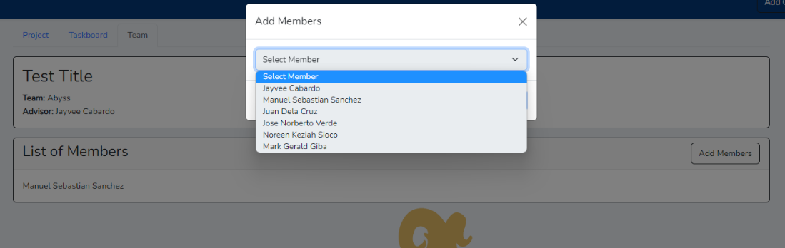

Figure 43 Pop up Modal for adding and giving permission to users to view the Project

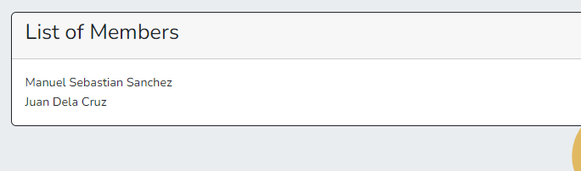

Figure 44 List of Members at Team Page of TAPM

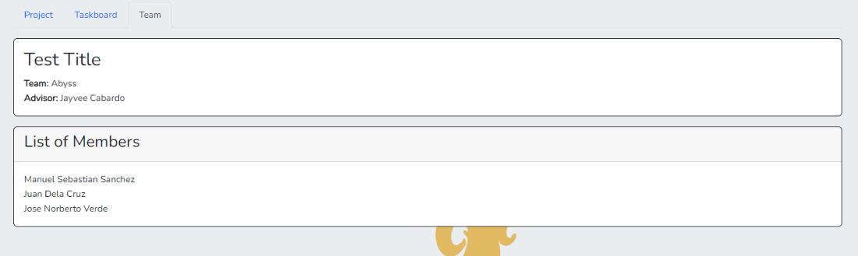

Figure 45 Team Page of TAPM for Students View

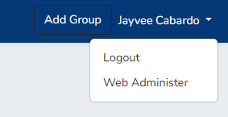

Figure 46 Button to Admin View of TAPM for PDO

Figure 46 is the visualization of how PDO can change their view into Admin. Figure 47 is the modal pop up that will prompt the PDO to change their view.

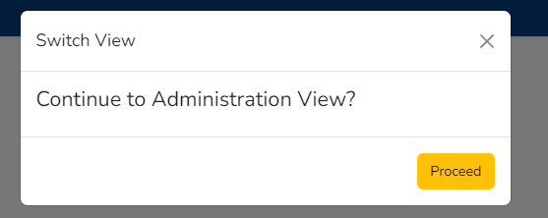

Figure 47 Pop Up Modal for Confirmation of Admin View

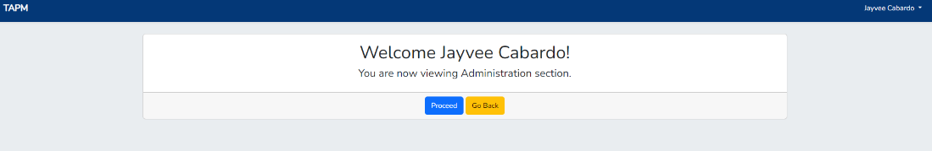

Figure 48 Welcome Page of Admin View of TAPM

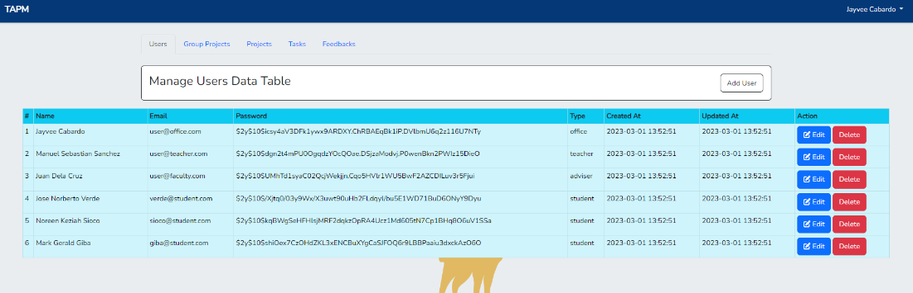

Figure 49 User Data Table Page of Admin View of TAPM

Figure 49 is the User Table Page. Here, the Admin can add or manage the credentials of users available in the system.

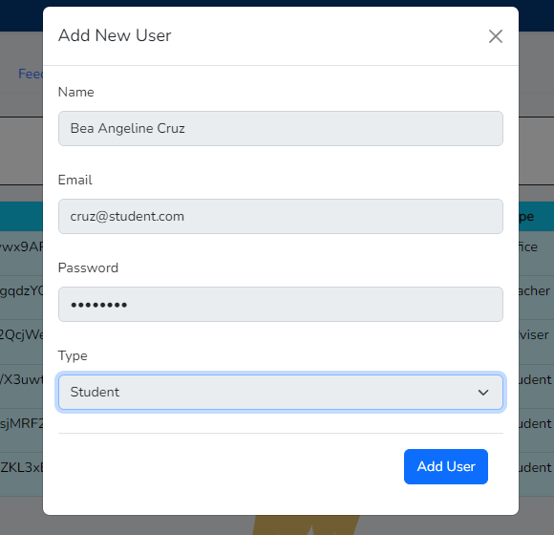

Figure 50 Pop Up Modal of Add New User for Admin of TAPM



Figure 51 Seeded View after Successful Addition of Users

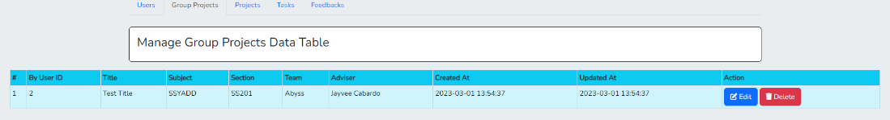

Figure 52 Group Project Data Table Page of Admin View of TAPM

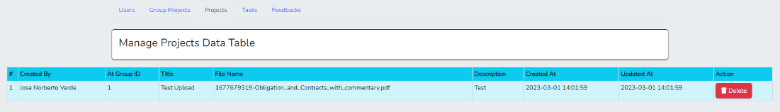

Figure 53 Project Data Table Page of Admin View of TAPM

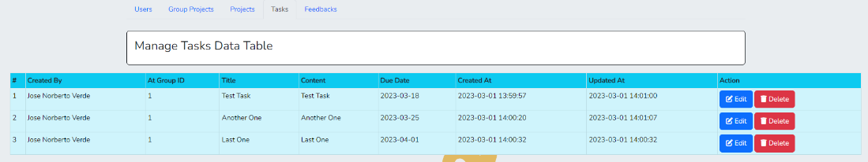

Figure 54 Tasks Data Table Page of Admin View of TAPM

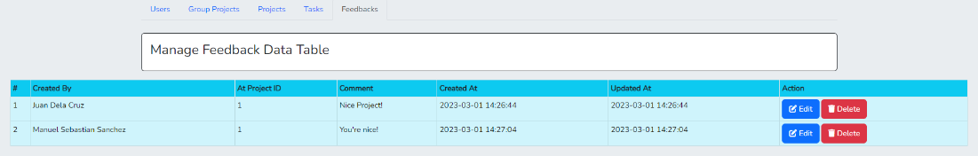

Figure 55 Feedback Data Table Page of Admin View of TAPM

Figure 52, Figure 53, Figure 54, and Figure 55 are the Data table for Groups, Projects, Tasks, and Feedbacks seeded to the system.

## Use Classes and Characteristics

Table 7 Roles and Description of Use Classes

|  |  |
| --- | --- |
| Roles | Description |
| Client | The client is the Project Development Director, who needs a personalized product for tracking and monitoring. |
| Adviser | This user approves or disapproves the project requested and oversees advising the team for its development. |
| Student | This user is one of the end-users that will be using the product. |
| Project Development Office | This user will take up the success of the project |

# Conclusion

To summarize, the researchers have finished establishing a system that ensures student groups meet deadlines. TAPM (Tracking Activity Project Management) can already create a project and set a deadline. Before this semester ends, the researchers targeted to accomplish the objective “To create a process for providing feedback and evaluation on student research team progress in an online classroom setting." and "To improve communication channels with student research teams in an online classroom setting.". For the next iteration, the app should be done and the objective that we are trying to accomplish at this point is "To develop a system for monitoring and tracking the progress of individual student research teams in an online classroom setting.”

# References

|  |  |
| --- | --- |
| [1] | "Kissflow Inc.," 22 02 2022. [Online]. Available: https://kissflow.com/project/project-management-challenges/. [Accessed 29 April 2022]. |
| [2] | P. Fic, 2019. [Online]. Available: https://www.fnm.um.si/wp-content/uploads/2019/04/Dianoia_2019_1.pdf#page=15. [Accessed 29 April 2022]. |
| [3] | "Everhour," Everhour, 2015. [Online]. Available: https://everhour.com/blog/how-to-use-notion/#:~:text=You%20can%20call%20Notion%20a,art%2C%20and%20organize%20project%20details.. [Accessed 28 October 2022]. |
| [4] | "Microsoft 365," Microsoft, 26 January 2023. [Online]. Available: https://learn.microsoft.com/en-us/office365/servicedescriptions/project-online-service-description/microsoft-planner-service-description. [Accessed 15 november 2022]. |
| [5] | H. Kerzner, "Project management: a systems approach to planning, scheduling, and controlling.," John Wiley & Sons., 2013. |
| [6] | J. &. C. J. P. Gido, " Successful project management.," Cengage Learning., 2014. |

# Appendices

## Appendix A: Project Vision

Our vision for Tracking Activity and Project Management is to develop an intuitive and user-friendly application that simplifies the process of tracking and managing multiple projects for project advisors. Our aim is to increase productivity and efficiency for teams by providing features such as task tracking, team collaboration, and a project task board. The system will enable project advisors to effectively oversee and monitor the progress of projects completed by students, helping them stay on track and meet their goals. Our goal is to empower project advisors and their teams to manage projects more efficiently.

## Appendix B: Schedule

Figure 56 Schedule Run of TAPM

Figure 57 Schedule Chart of TAPM

## Appendix C: Product Roadmap

Table 8 Product Roadmap of the Project

|  |  |  |
| --- | --- | --- |
| SNTSDEV | SSYADD | SCSPROJ |
| * Finding Client * Requesting for project proposals/advisor * Meeting with Client * Identifying problems/user stories. * Research Paper * SOP * Objectives * Gap analysis * Proposing Solution * Sending draft for confirmation with advisor. * Low-fidelity prototype * Identifying features of the product. * Confirmation with client about said features. * Creating high fidelity-prototype. * Revision of paper * Checking with Panelist. * Making of Presentation   PowerPoint Presentation | * Design Thinking Stages * Creation of documents for design thinking stage 1-5. * Prototype * Creating a prototype through Figma to give the client a view of how the system would look like. * Diagrams * Data Flow Diagram * User Cases * Entity Relationship Diagram * Revision of Paper * Presentation | * Diagrams * Context Diagram * Activity Diagram * Object Diagram * Sequence Diagram * State Machine Diagram * Class Diagram * Deployment Diagram * System * Creation of the Database of the System * Creation of the Actual System through a website with the use of Laravel Framework * Revision of Paper * Presentation |

## Appendix E: Team Meetings

37 Minutes

32 Minutes

16 Minutes

1 Hour

1hr & 30mins.

## Appendix F: Source Code

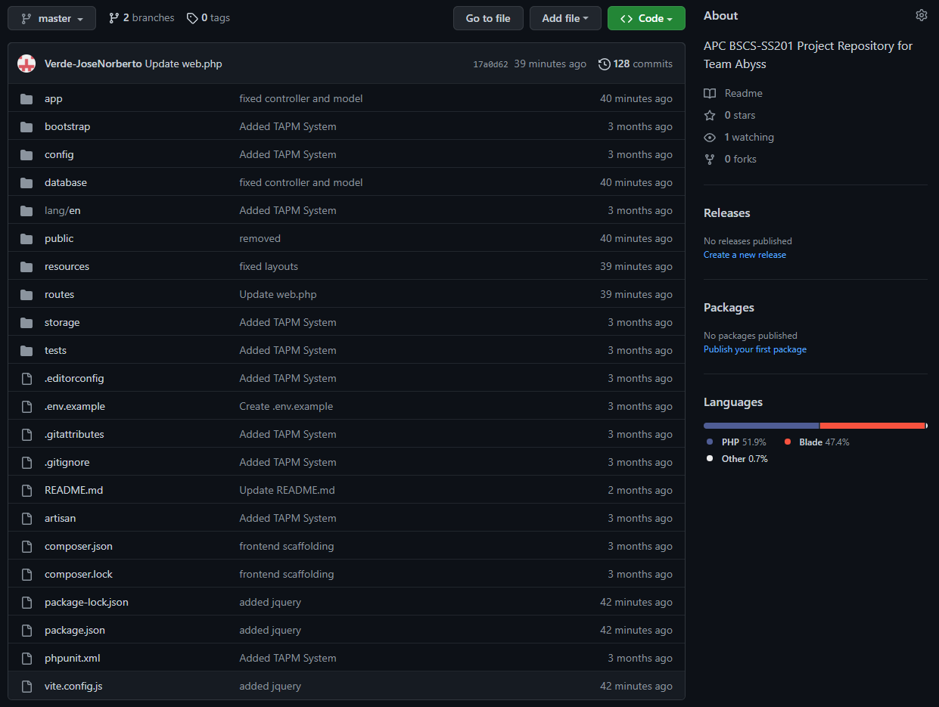

Figure 58 Source Code at GitHub

[*https://github.com/Verde-JoseNorberto/TAPM-System*](https://github.com/Verde-JoseNorberto/TAPM-System)